**Final Year Project**

**Seekloo**

**Smart Tutor Finding Android Application**

**FYP Team**

**Mr. Afnan Nadeem**

**Mr. Osama Nadeem**

**Mr. Uzair Nadeem**

**Supervised by**

**Ms. Zain Iqbal**

**Co-Supervised by**

**Mr. Abid Jameel**

**Department of Computer Science**

**National University of Computer and Emerging Science**

**Chiniot-Fasailabad, Pakistan**

**2019**

|  |  |  |  |
| --- | --- | --- | --- |
| **Name** | **Date** | **Reason For Changes** | **Version** |
| Osama Nadeem  Uzair Nadeem  Afnan Nadeem | 05/20/2019 | Use Case Diagram | 2.0 |
|  |  |  |  |

**Intellectual Property Right Declaration**

**This is to declare that the work under the:**

**Title: Sekhloo (Smart Tutor Finding Android Application) carried out in partial fulfillment of the requirements of:**

⬜**BS FYP** ⬜**MS Research Survey** ⬜**MS Thesis** ⬜**Course Project**is the sole property of the National University of Computer and Emerging Science, and is protected under the intellectual property right laws and conventions. It can only be considered/used for purposes like extension for further enhancement, product development, adoption for commercial/organizational usage, etc., with the permission of the University This above statement applies to all students and faculty.

Date: ______________

Student 1

Name: Afnan Nadeem

Signature: _______________

Student 2

Name: Uzair Nadeem

Signature: _______________

Student 3

Name: Osama Nadeem

Signature: _______________

Supervisor (Faculty)

Name: Miss. Zain Iqbal

Signature: _______________

**Anti-Plagiarism Declaration**

This is to declare that the above publication produced under the:

**Title: Sekhloo (Smart Tutor Finding Android Application) is** the sole contribution of the author(s) and no part hereof has been reproduced on **as it is** basis (cut and paste) which can be considered as **Plagiarism.** All referenced parts have been used to argue the idea and have been cited properly. I/We will be responsible and liable for any consequence if violation of this declaration is determined.

Date: ______________

Student 1

Name: Afnan Nadeem

Signature: _______________

Student 2

Name: Osama Nadeem

Signature: _______________

Student 3

Name: Uzair Nadeem

Signature: _______________

**Executive Summary:**

This report includes vision of the product that provides the information regarding the scope, purpose and market impact of the product. SRS, which explains the overall functionality of product and external interface requirements. Furthermore, the Use cases explain scenarios of the product for the user and developer. Use case diagram illustrates the use cases in visual format. Expanded use cases describe the use cases in detail for clear comprehension. Domain model provides a conceptual model of product that incorporates both behavior and data. System Sequence diagrams are visual summary of individual use cases. Operational contracts identify system changes when an operation happens. ERD and Class diagram shows the logical structure of the system.

**Table of Contents**

I. Project Vision 12

1. Vision Document Introduction 12

1.1. Purpose 12

1.2. Scope 12

2. Positioning 13

2.1. Business Opportunity 13

2.2. Problem Statement 13

2.3. Product Position Statement 14

3. Stakeholders and User Descriptions 15

3.1. Market Demographics 15

3.2. Stakeholder Summary 15

3.3. User Summary 16

3.3.1. User 16

3.4. User Environment 16

3.5. User Profile 17

3.5.1. User 17

4. Product Overview 18

4.1. Product Perspective 18

4.2. Summary and Capabilities 18

4.3. Assumptions and Dependencies 19

4.4. Cost and Pricing 19

4.5. Licensing and Packaging 19

5. Product features 20

5.1. Class Room 20

5.2. Personality test 20

5.3. Tutor Recommendations 20

5.4. Feed back 20

5.5. Post Newsletter 20

5.6. Time Table Scheduling 21

5.7. Voice/Video Calling 21

6. Constraints 21

6.1. Usability 21

6.2. Performance 21

7. Quality Ranges 21

8. Precedence and Priority 22

9. Other Requirements 22

9.1. Applicable Standards 22

9.2. System Requirements 22

9.3. Performance Requirements 23

10. Documentation Requirements 23

10.1. User Manual 23

10.2. Installation document 23

11. Feature Attributes 23

11.1. Status 23

11.2. Benefits 24

11.3. Effort 24

11.4. Stability 24

II. Software Requirement Specification 25

1. Introduction 25

1.1 Purpose 25

1.2 Document Conventions 25

1.3 Intended Audience and Reading Suggestions 25

1.4 Product Scope 26

2. Overall Description 26

2.1 Product Perspective 26

2.2 Product Functions 26

2.3 User Classes and Characteristics 27

2.3.1 Student/Tutor 27

2.3.2 Admin 27

2.4 Operating Environment 27

2.5 Design and Implementation Constraints 27

2.5.1 Performance 27

2.5.2 Usability 27

2.6 User Documentation 28

2.6.1 User Manual 28

2.7 Assumptions and Dependencies 28

3. External Interface Requirements 28

3.1 User Interfaces 28

3.1.1 Student 28

3.1.2 Tutor 29

3.2 Hardware Interfaces 29

3.3 Software Interfaces 29

3.4 Communications Interfaces 29

4. Other Nonfunctional Requirements 29

4.1 Performance Requirements 30

4.2 Safety Requirements 30

4.3 Security Requirements 30

4.4 Software Quality Attributes 30

4.4.1 Efficiency 30

4.4.2 Accessibility 30

4.4.3 Instability 31

III. Use Case Diagram 32

IV. Use Cases 33

1. Login 33

2. Registration 33

3. Enter Academic Information 34

4. Post Offer 34

5. Personality Test 35

6. React Request 35

*Table 14: React Request* 35

7. Video Voice Calling 35

8. Give Feedback 36

9. Read Newsletter 36

10.Create Classroom 36

11. Select Tutor 37

12. Post Newsletter 37

13. Send Request 37

14. Timetable Scheduling 37

15. Share Resources 38

V. Expanded Use Cases 38

1. Login 38

2. Register Account 40

3. Enter Academic Information 41

4. Post Offer 42

5. Personality Test 43

6. React Request 44

7. Video Voice Calling 45

8. Give Feedback 46

9. Read Newsletter 47

10. Create Classroom 48

11. Select Tutor 49

12. Post Newsletter 50

13. Timetable Scheduling 51

14. Send Request 52

15. Share Resources 53

VI. Domain Model 54

VII. System Sequence Diagram 55

1. Registration 55

2. Enter academic information 55

3. Login 56

4. Share resources 56

5. Post offer 57

6. Create classroom 57

7. Gives feedback 58

8. Select tutor 58

9. Send request to tutor 59

10. Make videocall 60

11. Post newsletters 61

12. Read newsletter 61

13. Gives personality test 62

14. React requests 62

VIII. Operational Contracts 63

1. Login 63

2. Create Classroom 63

3. Find Tutor 64

4. Request Tutor 64

5. React to request 65

6. Give Feedback 65

7. Enter Academic Information 66

8. Post Newsletter 66

9. Receive Video Call 67

10. Request Video Call 67

IX. Sequence Diagram 68

X. Class Diagram 69

XI. Entity Relationship Diagram 70

XII. Activity Diagram 71

**List of Figures**

Figure 1: Product Perspective 9

Figure 2: Use Case 29

Figure 3: Domain Model 55

Figure 4: Registration 56

Figure 5: Validate Session 56

Figure 6: Start Exam 57

Figure 7: Login 57

Figure 8: Customize Exam Type 58

Figure 9: Enroll Examinee 58

Figure 10: View Evidence 59

Figure 11: View Final Report 59

Figure 12: Submit Exam 60

Figure 13: Upload Exam 60

Figure 14: Text Detection 61

Figure 15: Phone Detection 61

Figure 16: Voice Identification 62

Figure 17: Active Windows Identification 62

Figure 18: Face Verification 63

Figure 19: Gaze Estimation 63

Figure 20: Generate Final Report 64

Figure 21: Audio Processing 64

Figure 22: Video Processing 65

Figure 23: Sequence Diagram 76

Figure 24: Class Diagram 77

Figure 25: Entity Relation Diagram 78

Figure 26: Activity Diagram 79

**List of Tables**

Table 1: Problem Statement 4

Table 2: Product Position Statement 4

Table 3: Stake Holder Summary 6

Table 4: User 7

Table 5: User Profile 8

Table 6: Product Overview 9

Table 7: Precedence and Priority 13

Table 8: Feature Attributes 15

Table 9: Login 30

Table 10: Registration 30

Table 11: Start Exam 30

Table 12: Validate Session 31

Table 13: Submit Exam 31

Table 14: Customize Exam Type 32

Table 15: Enroll Examinee 32

Table 16: View Final Report 32

Table 17: Upload Exam 33

Table 18: View Evidence 33

Table 19: Text Detection 33

Table 20: Phone Detection 34

Table 21: Voice Identification 34

Table 22: Active Windows Identification 34

Table 23: Gaze Estimation 35

Table 24: Generate Final Report 35

Table 25: Audio Processing 35

Table 26: Video Processing 36

Table 27: Login 66

Table 28: Upload Committed Exam 66

Table 29: Set Exam Type 67

Table 30: View Final Report 67

Table 31: View Evidence 68

Table 32: Register Examinee 68

Table 33: Verify Session 69

Table 34: Submit Exam 70

Table 35: Head Angel Estimation 70

Table 36: Display Detect 71

Table 37: Detect Text 71

Table 38: Audio Classification 72

Table 39: Match Face Features 72

Table 40: Audio Processing 73

Table 41: Video Preprocessing 73

Table 42: Analyze Packet 74

Table 43: Analyze Active Apps 75

Table 44: Generate Final Report 75

# I. Project Vision

# 1. Vision Document Introduction

This section of the document would provide a brief introduction of the vision document. The information regarding the product such as its purpose, scope and market impact depending upon the opportunities in the market as well as the current position of the product. The detail about the product functionality, its problem statement, solution, assumptions, dependencies and features, cost and pricing of similar products, as well as requirements of the product. The information regarding the product constraints, stakeholder and user are covered as well. Some of the information in the vision document is arranged in tabular form, this makes the information more perceivable and easily observable, for a good understanding of the document.

### 1.1. Purpose

The main purpose of this product is to provide a feasible environment for those people, who are looking for tutors and academies. Sekhloo provide a dedicated easy to use platform for hiring, testing, interviewing tutors and instructors of these online courses. Helping find a right person for you children while maintaining absolute integrity.

### 1.2. Scope

In this section we will discuss the scope of the project. This Product targets the Android user clients from all around the world. Sekhloo is a mobile application, that will be developed to work on the Android Platform. Sekhloo works intelligently, so any query and request performed by the user will automatically be mapped with the list of options that are most relevant to your request, out of those the user can select any one. The scope of the project is given below:

* Sekhloo is beneficial for both students and teachers.
* Sekhloo will continuously process the requests of the users and act accordingly.
* Sekhloo will be a blend of all the modern techniques to provide, safe and reliable e-learning opportunity.

# 2. Positioning

This section describes how the positioning helps Sekhloo in business and which problem motivated us to work on this project. Section 2.1 explains the business opportunity for us by our Software. Section 2.2 explains the problem statement that gave us a cause to work on this project. Section 3.3 explains the product position statement explaining who would be the customers, why they need our product and what is the impact of our product on the targeted customers.

### 2.1. Business Opportunity

The world is getting smarter, so as the students. So, the students are moving towards online education instead of traditional education system. More than 7.1 million students are studying at least one online course. Due to the migration of students from traditional to online and distant education, there has been an increased focus on the development of smart tutor finding applications with e-learning opportunities, but there has not been a single ground shaking development in the context to make this software completely automatic. Today academic institutes are using websites for this purpose but they don’t offer real time matching and e-learning facilities, hence the business opportunities are clearly prominent.

### 2.2. Problem Statement

In this section we will discuss the problem statement of the project. The following table will describe further the problem, affects and its impact.

*Table 1: Problem Statement*

|  |  |
| --- | --- |
| **The problem of** | Finding a competent and reliable instructor  that closely matches the requirements of the  student and the parents, their interview and credibility check, E-Learning opportunities, |
| **Affects** | Teacher and students in general. |
| **The impact of which is** | A student can select a teacher from home easily or even take online classes and both teacher and students can relax while the accuracy of finding the perfect candidate increases. |
| **A successful solution would be** | A smart application that will match the students and teachers, enables them to schedule interview and classes, update the user about their progress, feedback and news from educational institutes. |

### 2.3. Product Position Statement

In this section we will discuss the product position statement. The following table will describe further.

*Table 2: Product Position Statement*

|  |  |
| --- | --- |
| **For** | Teachers, students and coaching centers |
| **Who** | Have issues in their academics and seek counseling or the people that are looking for students to earn an honest living. |
| **The** | Android application that finds tutors for the students |
| **That** | Would automatically match your request in real time with the best possible options. It also provides interviews facilities and e-learning opportunities. |
| **Unlike** | The currently available online platforms that only match keywords and rarely provides optimal results and no other features are incorporated |
| **Our product** | Is fully automated and train itself according to user requests via learning algorithms and data mining techniques, and is capable of finding intelligent answers to your queries by mapping them using modern ways. |

# 3. Stakeholders and User Descriptions

This section describes about the market demographics, stakeholder and user summary, discussion about the competitors if any.

### 3.1. Market Demographics

The market for home tutoring and E-Learning is expanding at a fast pace. The computer-based assessment market is a promising one with growing internationalization of education, Massive Open Online Courses (MOOC) usage, and certifications from professionals. Because of these trends, there’s huge potential. The target market segment involves educational institutes and multiple test centers who wants students that are in the that neighborhood.

### 3.2. Stakeholder Summary

In this section we will discuss the stakeholder summary. The following table will describe further.

*Table 3: Stakeholder Summary*

|  |  |  |
| --- | --- | --- |
| **Name** | **Description** | **Responsibilities** |
| Student | These are primary stakeholders of the system. | By using the android application ‘Sekhlooo’ users will be able to find tutors. |
| Tutor | These are primary stakeholders of the system. | By using the android application ‘Sekhlooo’ users will be able to find an honest way to earn living(students). |
| Requirements Engineer | This stakeholder works with customers and other stakeholders to translate needs into requirements. | Specifies domains, non-functional, and functional requirements as needed. |
| Software Architect | This stakeholder is a primary lead in the development of the project. | Responsible for overall architecture of the system, and guides overall design and implementation of the system. |
| Project Manager | This stakeholder supervises the entire development & activities of the project. | Plans, manages, allocates resources, decides priorities, coordinates with the users and customers, and keeps the project team focused. |

### 3.3. User Summary

In this section we will discuss the user summary.

#### 3.3.1. User

In this section we will discuss the users of the system. The following table will describe further about the user.

*Table 4: User*

|  |  |  |  |
| --- | --- | --- | --- |
| **Name** | **Description** | **Responsibilities** | **Stakeholder** |
| Student and tutor | Primary End user of the system | Uses application to find tutor and students respectively for home tuitions and E-learning opportunities. | Self |

### 3.4. User Environment

This section describes the working environment of the targeted user. Here are some things mentioned below that would be considered in user’s working environment:

* The Sekhloo android application that will be used by those institutes who are looking for the students in their locality or those institutes that aim to provide home tuitions to their clients.
* The unique environmental constraint is that it requires a possession of a android phone with a working GPS and internet connection.
* The platform currently in use is android studio and it probably wouldn’t be changed
* Any task the user wants to perform on the system will be considered for the future performance of the system.

### 3.5. User Profile

In this section we will discuss the user profile of the system.

#### 3.5.1. User

In this section we will discuss the user profile of the system. The following table will describe the user profile.

*Table 5: User Profile*

|  |  |
| --- | --- |
| **Representative** | Student/Tutor. |
| **Description** | The main users that will use the deployed system. |
| **Responsibilities** | The users will be able to find student/tutors according their demands and skills. |
| **Success Criteria** | The Success criterion would be a successful matching of the request with the most suitable option. |
| **Deliverables** | The properly working windows-app  Find tutor.  Schedule Interviews.  E-Learning Opportunities.  Update news  Personality test.  User Feedback & Rating. |
| **Issues** | The performance is a huge issue because we would be running a lot of algorithms simultaneously. Moreover, the post server processing will prove to be a great hindrance. |

# 4. Product Overview

This section will describe the perspectives in section **4.1**, capabilities of product in section **4.2**.

### 4.1. Product Perspective

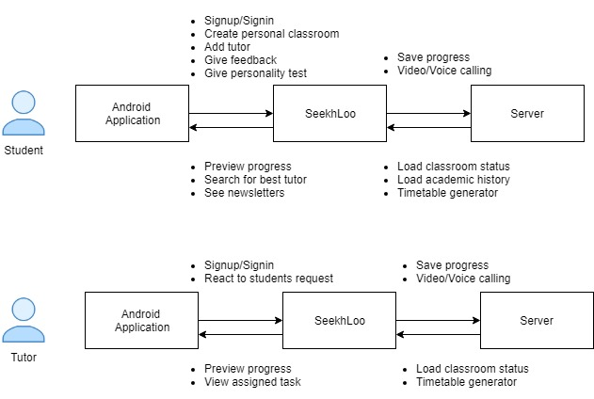

*Figure 1: Product Perspective*

### 4.2. Summary and Capabilities

In this section we will discuss the summary and capabilities of the system. The following table will describe in a further detail.

*Table 6: Product Overview*

|  |  |
| --- | --- |
| **Customer Benefit** | **Supporting Features** |
| Efficiency and accuracy | Sekhloo will be programed to map information i.e. data from signup, coordinates, and requirements into matrices and then that will be processed and stored in database. This makes it easy to find best matches which increases the accuracy and efficiency of the system. |
| Easy to use | It provides a very interactive graphical user interface which helps the user to learn and operate the application without any prior knowledge |
| Security | With Sekhloo intelligent use of data, system will keep all the private information hidden until a user allows someone the access. Moreover, a user may report any abnormal behavior at any time and a serious response is guaranteed. |

### 4.3. Assumptions and Dependencies

* It is assumed that the information provided by the user is not fabricated
* It is assumed that internet is working properly.
* Sekhloo is dependent on hardware components and good internet connection.

### 4.4. Cost and Pricing

We would be needing any hardware for this. The only thing we require is video calling API which can be 65$ per month. It is a monthly investment. Moreover, the only other cost would be the time and effort required to develop the application.

### 4.5. Licensing and Packaging

There is no need to purchase any special kind of license for the development of our system because system will be an android application

# 5. Product features

This section describes the product features and services provided by the application.

### 5.1. Class Room

It is the space in which the student and the teacher will interact, for a particular subject. The class room will only be created if the teacher and the student both are on board. It will have the functions of video calling, voice calling and resource sharing. User can upload and download resources as per their will. Notifications and email responses will be generated to notify the users. Each classroom will have a unique subject, so for each subject a different classroom will be created.

### 5.2. Personality test

A personality test is a series of question to access the human’s personal constructs. It is used to analyze the student’s personal traits and to find the hidden gems. This test will allow them to understand themselves better and the others to help them achieve their goals.

### 5.3. Tutor Recommendations

Data from the sign up and requests will be mapped on a matrix and the information gained will be utilized to process the request and give the student, recommendations of the teachers on the run time that are most similar to the specifications.

### 5.4. Feed back

One of the most important things to improve user experience is feedback, Therefore, in this component we will ensure regularity in two-way feedbacks. User will be forced to submit monthly feedbacks, in case of negligence some features will be restricted to use till the feedback is submitted.

### 5.5. Post Newsletter

Our application Seekhloo offers a unique way to inform the students/teachers about the updates from our National Universities and important dates of Government positions. Admin will regularly post newsletter that will be visible to all the users. This will not only engage the users to check the application regularly but also update them timely about future events.

### 5.6. Time Table Scheduling

This feature will resolve the conflict that a teacher won’t be available for the timeslot in which he is already engaged with a student. An automatic timetable for the teacher and student will be generated for the ease to avoid any clashes.

### 5.7. Voice/Video Calling

This feature will enable the users to schedule their interviews online, if they want to have their sessions virtually, they can always use the feature of video calling and screen sharing for a better and clear learning environment. This feature will be very helpful to those people who want learn/teach remotely.

# 6. Constraints

### 6.1. Usability

* The application will run only on android platform.
* There may be continuous transmission of audio and video files in the application in case of video calling
* The application will work only when opened, no background usage will be done

### 6.2. Performance

* Unstable transfer rate of internet may affect the suggestion results of the application.

# 7. Quality Ranges

The quality of the output of system is dependent on different limitation of hardware and software techniques. So, the main limitations on which the quality is depending are given below.

* Seekhloo’s performance highly depends on the completeness and validity of the information provided by the user.
* Faulty hardware may have massive impact on app’s video calling feature

# 8. Precedence and Priority

The system works on six main modules that are arranged on the priority basis. Following table shows all the precedence and priority of above-mentioned features.

*Table 7: Precedence and Priority*

|  |  |
| --- | --- |
| **Priority** | **Feature (By Number Above)** |
| High | 5.1, 5.3, 5.4, 5.6, 5.7 |
| Medium | 5.2, |
| Low | 5.5 |

# 9. Other Requirements

### 9.1. Applicable Standards

The product has to follow the certain designing and other rules defined by Google. The app follows

* Android design guideline and uses common UI patterns and icons.
* The app supports standard system back button navigation and doesn’t make use of any custom on screen back button prompts.
* Pressing the home button at any time navigates to the home screen of the device.
* Notifications follow android design guidelines. The app uses notifications only to indicate a change in context related to user personally. Expose information/controls relating to an ongoing event.

### 9.2. System Requirements

System requirements consist of some of the hardware and software requirements that are given below.

* Operating system can Android 6.0 or higher.
* Internet is required for the application to work.

### 9.3. Performance Requirements

* **Processor and Ram:** The mobile phone should have enough ram and processor to be able to process the video calling feature so that the screen sharing and e-learning feature can be used to its best.
* **Hardware Equipment:** All hardware equipment i.e. camera and microphone must be working properly.
* **Internet Connection:** The mobile should be should be connected to internet throughout the session.

# 10. Documentation Requirements

This section describes the documentation that must be developed to help the successful application deployment.

### 10.1. User Manual

The application is Android based so directions will available with the application deployment.

### 10.2. Installation document

Application is Android based so installation of application will be required.

# 11. Feature Attributes

### 11.1. Status

In this section we will discuss the status of the application. The following table will describe further.

*Table 8: Feature Attributes*

|  |  |
| --- | --- |
| **Proposed** | A smart application that will match the students and teachers, enables them to schedule interview and classes, update the user about their progress, feedback and news from educational institutes. |

### 

### 11.2. Benefits

Seekhloo works intelligently, it gives suggestions on the run time after you enter your request and gives you closely related options. Moreover, it also cost much less then hiring agents or going to through the ad agencies.

### 11.3. Effort

As accuracy is the main concern for this project, that’s why gathering correct data and choosing right algorithm requires more effort. All of group members will focus on these tasks first. After that, implementation by using best techniques requires effort of all group members.

### 11.4. Stability

This section describes the stability of features how much change would be entertained on the basis of user (student, supervisor and FYP panel) feedback. Currently, it is the first iteration of document, so no change has been performed.

# II. Software Requirement Specification

# 1. Introduction

This section will provide you product requirements and scope. It includes overall function of the product and external interface requirements. In the last, it includes system features and non-functional requirements.

### 1.1 Purpose

The main purpose of this document is to give detail description about different requirements of our project. Secondary purpose is to define all the possible functions of our project. Detailed description about the features, interfaces and requirements is given in this document. It is a roadmap which provides high level and detailed technical requirements.

### 1.2 Document Conventions

The document conventions include:

1. Main Heading size is 16
2. Sub heading size is 14
3. Font size is 11
4. Font Family is Times New Roman
5. Line Spacing is 1.5

### 1.3 Intended Audience and Reading Suggestions

This document is meant for,

* Developers: Project developers have an advantage of quickly understanding the methodology enabled.
* Users: The users of the system will get a clear idea of the software and hardware requirements to be engaged.
* Testers: Will have complete knowledge of how to test the system for accuracy.

### 1.4 Product Scope

In this section we will discuss the scope of the project. This Product targets the Android user clients from all around the world. Seekhloo is an Automated smart tutor finding application, that will be developed to work on the Android phones. Seekhloo works intelligently, so any request by the user will automatically be entertained with an accuracy of more than 85%, which is much more than any human proctor. The scope of the project is given below:

* Seekhloo is beneficial for both students and teachers.
* Seekhloo will suggest tutor to the students and automatically create classroom if you confirm a tutor.
* Seekhloo will make schedules automatically of the users
* Seekhloo will regularly ask for user feedback and use it for further suggestions.

# 2. Overall Description

### 2.1 Product Perspective

Currently, there are many websites that provide E-Learning opportunities and Tutor recommendations but they are all hardcoded and don’t offer all the features at one place. More over their process is transparent and there is a chance of potential data leakage.

### 2.2 Product Functions

The main functionality of Seekhloo will be,

* Tutor Recommendations
* Video Calling Features
* Class Room creation
* Smart Scheduling
* Feedback
* Personality Test

### 2.3 User Classes and Characteristics

#### 2.3.1 Student/Tutor

This section describes the characteristics of the users. Users should have

experience of using Android application.

* Experience of installing and using Android applications.
* Adequate level of understanding of different interfaces.
* User should have a complete understanding of the features of product.

#### 2.3.2 Admin

This section describes the characteristics of the Admin. Admin should have experience

of using Android application.

* Experience of using android applications.
* Adequate level of understanding of different app interfaces.
* Admin should have complete knowledge of the features of product.

### 2.4 Operating Environment

For this project video calling feature, the operating environment must be properly lighted and it must be isolated from distraction noises. moreover, to make constant connection with internet is required.

### 2.5 Design and Implementation Constraints

This section is about different constraints which will reduce the efficiency of the product. There are certain design and implementation constraints. These constraints are described below.

#### 2.5.1 Performance

Unstable transfer rate of internet may affect the results of the application.

#### 2.5.2 Usability

* The application will run only on Android platform.
* There will be continuous transmission of audio and video files in the application if you are using certain E-Learning features.

### 2.6 User Documentation

This section defines the documentation that must be developed to support the development of project successfully. It involves the Vision of project, use cases, SRS, different reports, user manual etc.

#### 2.6.1 User Manual

As the system is a windows application, a concise manual will be developed for users to get started with the application. Some reports and SRS documents might be provided to the project developers for updating and maintenance.

### 2.7 Assumptions and Dependencies

In this section we will discuss the assumption and dependencies of the system.

* It is assumed that the users don’t enter false information.
* It is assumed that internet is working properly at moderate bandwidth rate.
* Seekhloo is dependent on hardware components, good internet connection and correct information entered by the user at various levels.

# 3. External Interface Requirements

### 3.1 User Interfaces

#### 3.1.1 Student

Student interface will be similar to other E-learning applications, where student can first register their account, then perform login. After which he will be asked to verify himself and right after validation, after that the student can enter/search for tutors by entering all the relevant information. Student is allowed to use all the other features of the application.

#### 3.1.2 Tutor

Tutor interface will be similar to other E-learning applications, where tutor can first register their account, then perform login. After which he will be asked to verify himself and right after validation, he will be given a dashboard where he can receive/react requests of the students. On accepting the request, he will be entered in the classroom. Moreover, after successful login he is free to use other application features.

### 3.2 Hardware Interfaces

Seekhloo is highly dependent on three hardware components.

* GPS, which will be used for location of the users.
* Front Camera, which will be used for video calling.
* Microphone, which will used for voice transmission.

### 3.3 Software Interfaces

Seekhloo requires a constant connection with server, in which it will transmit user’s information, which then will be processed by the server to suggest closely related options.

### 3.4 Communications Interfaces

As Seekhloo is an Android based application. It has to contact with the server. To establish contact with the server, we will be using HTTP V1 API protocol to send data files and receive results after server has done processing those files.

# 4. Other Nonfunctional Requirements

* Following are the non- **Processor and Ram:** The mobile phone should have enough ram and processor to be able to process the video calling feature so that the screen sharing and e-learning feature can be used to its best.
* **Hardware Equipment:** All hardware equipment i.e. camera and microphone must be working properly.
* **Internet Connection:** The mobile should be should be connected to internet throughout the session.

functional requirements of our project.

### 4.1 Performance Requirements

Following are the performance requirements of the system.

### 4.2 Safety Requirements

The product is safe as post processing is being done, so the user’s data is already preserved in database and could be used again, if the server crashes.

### 4.3 Security Requirements

Following are the security requirements of the system

* The product is secure as post processing is being done on server side instead of client side, so the results will be quite reliable and accurate.
* The user’s records are kept on server instead of user’s own phone so the data would be quite secured.

### 4.4 Software Quality Attributes

Following are the software quality attributes of our system

#### 4.4.1 Efficiency

As the system is fully automatic, so there are no chances of human error, hence the system is more efficient than traditional matching applications.

#### 4.4.2 Accessibility

The product is fully designed for those students, who could not reach the academies or institute’s campus, it allows them to seek guidance in or from home. Due to which it is accessible to almost every person.

#### 4.4.3 Instability

The system will perform most of its processing on server due to which the installation of application on phone is easy and takes less time.

# 

# III. Use Case Diagram



*Figure 2: Use Case*

# IV. Use Cases

This section of the documents shows all the ‘High level Use Cases’ of Seekhloo.

## 1. Login

*Table 9: Login*

|  |  |
| --- | --- |
| **Use Case ID** | UC-01 |
| **Use Case** | Login |
| **Actors** | Tutor, Student, Admin |
| **Type** | Primary |
| **Description** | It takes user’s credentials and provide him access to their respective dashboards. |

## 2. Registration

*Table 10: Registration*

|  |  |
| --- | --- |
| **Use Case ID** | UC-02 |
| **Use Case** | Registration |
| **Actors** | Tutor, Student |
| **Type** | Primary |
| **Description** | Tutor and student registers themselves by providing their basic and academic information |

## 3. Enter Academic Information

*Table 11: Enter Academic Information*

|  |  |
| --- | --- |
| **Use Case ID** | UC-03 |
| **Use Case** | Enter academic information. |
| **Actors** | Tutor, Student |
| **Type** | Primary |
| **Description** | Tutor and student enter their academic information to register themselves. |

## 

## 4. Post Offer

*Table 12: Post Offer*

|  |  |
| --- | --- |
| **Use Case ID** | UC-04 |
| **Use Case** | Post Offer |
| **Actors** | Tutor |
| **Type** | Primary |
| **Description** | Tutor post offers about his available timing and his description. |

## 

## 5. Personality Test

*Table 13: Personality Test*

|  |  |
| --- | --- |
| **Use Case ID** | UC-05 |
| **Use Case** | Personality Test |
| **Actors** | Student |
| **Type** | Primary |
| **Description** | Student can give personality test to accessing his personal constructs. |

## 

## 6. React Request

## *Table 14: React Request*

|  |  |
| --- | --- |
| **Use Case ID** | UC-06 |
| **Use Case** | React Request |
| **Actors** | Tutor |
| **Type** | Primary |
| **Description** | Tutor can react to the offers sent by the students. |

## 7. Video Voice Calling

*Table 15: Video Voice Calling*

|  |  |
| --- | --- |
| **Use Case ID** | UC-07 |
| **Use Case** | videos/Voice Calling |
| **Actors** | Tutor, Student |
| **Type** | Primary |
| **Description** | Tutor and student can initiate a video/voice calling feature for distance learning |

## 8. Give Feedback

*Table 16: Give Feedback*

|  |  |
| --- | --- |
| **Use Case ID** | UC-08 |
| **Use Case** | Give Feedback |
| **Actors** | Student |
| **Type** | Primary |
| **Description** | Student gives a feedback about its experience of how tutor perform. |

## 9. Read Newsletter

*Table 17: Read Newsletter*

|  |  |
| --- | --- |
| **Use Case ID** | UC-09 |
| **Use Case** | Read Newsletter |
| **Actors** | Student |
| **Type** | Primary |
| **Description** | Student read all the newsletters. |

## 10.Create Classroom

*Table 18: Create Classroom*

|  |  |
| --- | --- |
| **Use Case ID** | UC-10 |
| **Use Case** | Create Classroom |
| **Actors** | Student |
| **Type** | Primary |
| **Description** | Student create a classroom for a specific subject. |

## 11. Select Tutor

*Table 19: Select Tutor*

|  |  |
| --- | --- |
| **Use Case ID** | UC-11 |
| **Use Case** | Select Tutor |
| **Actors** | Student |
| **Type** | Primary |
| **Description** | Student select a tutor from the list of recommended tutors |

## 12. Post Newsletter

*Table 20: Post Newsletter*

|  |  |
| --- | --- |
| **Use Case ID** | UC-12 |
| **Use Case** | Post Newsletter |
| **Actors** | Admin |
| **Type** | Primary |
| **Description** | Admin can post the newsletter which will publish to all students |

## 13. Send Request

*Table 21: Send Request*

|  |  |
| --- | --- |
| **Use Case ID** | UC-13 |
| **Use Case** | Send Request |
| **Actors** | Student |
| **Type** | Primary |
| **Description** | Student send a request to tutor to join his classroom. |

## 

## 14. Timetable Scheduling

*Table 22: Timetable Scheduling*

|  |  |
| --- | --- |
| **Use Case ID** | UC-14 |
| **Use Case** | Time Table Scheduling |
| **Actors** | Server |
| **Type** | Secondary |
| **Description** | This use case helps tutor to eliminate clashes in their time table |

## 15. Share Resources

*Table 22: Share Resources*

|  |  |
| --- | --- |
| **Use Case ID** | UC-15 |
| **Use Case** | Share Resources |
| **Actors** | Student, Tutor |
| **Type** | Primary |
| **Description** | This use case helps student and tutor to share their content. |

# V. Expanded Use Cases

Below are explained all the ‘Expanded Use Cases’ of Seekhloo

## 1. Login

*Table.1: Login*

|  |  |
| --- | --- |
| **Use case** | Login |
| **Actor** | Tutor, Student, Admin |
| **Type** | Primary. |
| **Pre-condition** | Internet connection |
| **Post-condition** | Respective interface becomes available |
| **Special Condition** | Valid Credentials |
| **Assumptions** | User knows his credentials |
| **Success Path** | * User Enter Credentials * System verifies credentials * Shows respective panel |
| **Alternate Path** | * Invalid Credentials, login again |
| **Triggers** | N/A |
| **Created By** | Afnan Nadeem |
| **Created On** | 01/04/2019 |
| **Revised By** | N/A |
| **Revised On** | N/A |
| **Frequency of Use** | Low |
| **Description** | It takes user’s credentials and provide him access to examinee or Admin panel. |

# 

## 2. Register Account

*Table. 2: Registration*

|  |  |
| --- | --- |
| **Use case** | Register Account |
| **Actor** | Tutor, Student |
| **Type** | Primary. |
| **Pre-condition** | It will be triggered by itself. |
| **Post-condition** | Registration request submitted. |
| **Special Condition** | Valid phone number |
| **Assumptions** | Correct basic information |
| **Success Path** | * Enter basic information * Enter academic information * Registration complete |
| **Alternate Path** | * Incorrect information * Incorrect phone number |
| **Triggers** | It will be trigger by itself. |
| **Created By** | Afnan Nadeem |
| **Created On** | 01/04/2019 |
| **Revised By** | N/A |
| **Revised On** | N/A |
| **Frequency of Use** | Low |
| **Description** | It takes user basic bio, and some sample profile pictures of examinee. |

# 

## 3. Enter Academic Information

*Table. 3: Enter Academic Information*

|  |  |
| --- | --- |
| **Use Case** | Enter academic information |
| **Actors** | Tutor, Student |
| **Type** | Primary |
| **Pre-condition** | Tutor or student complete first step of registration. |
| **Post-condition** | Registration successful |
| **Special Condition** | Working mobile phone |
| **Assumptions** | Reliable internet connection |
| **Success Path** | N/A |
| **Alternate Path** | N/A |
| **Triggers** | It will be triggered by itself. |
| **Created By** | Uzair Nadeem |
| **Created On** | 01/04/2019 |
| **Revised By** | N/A |
| **Revised On** | N/A |
| **Frequency of Use** | Low |
| **Description** | Tutor and student enter their academic information to register themselves |

## 

## 

## 

## 4. Post Offer

*Table 4: Post Offer*

|  |  |
| --- | --- |
| **Use Case** | Post Offer |
| **Actors** | Tutor |
| **Type** | Primary |
| **Pre-condition** | Tutor logged in |
| **Post-condition** | Offer posted successfully |
| **Special Condition** | Reliable internet connection |
| **Assumptions** | Tutor post verifiable information |
| **Success Path** | * Tutor selects to post an offer * Tutor enters his subject and description * Offer posted successfully |
| **Alternate Path** | Failed to post an offer |
| **Triggers** | It will be triggered by itself |
| **Created By** | Uzair Nadeem |
| **Created On** | 01/04/2019 |
| **Revised By** | N/A |
| **Revised On** | N/A |
| **Frequency of Use** | Low |
| **Description** | Tutor post offers about his available timing and his description. |

# 

## 5. Personality Test

*Table 5: Personality Test*

|  |  |
| --- | --- |
| **Use case** | Personality Test |
| **Actor** | Student |
| **Type** | Primary. |
| **Pre-condition** | Student logged in. |
| **Post-condition** | Results about his personality test |
| **Special Condition** | Reliable Internet connection |
| **Assumptions** | Working mobile phone |
| **Success Path** | * Student logged in * Student give personality test * Results of test shown |
| **Alternate Path** | * Disconnect from internet, fails to complete test |
| **Triggers** | It will be triggered by itself |
| **Created By** | Uzair Nadeem |
| **Created On** | 01/04/2019 |
| **Revised By** | N/A |
| **Revised On** | N/A |
| **Frequency of Use** | Low |
| **Description** | Student can give personality test to accessing his personal constructs |

# 

## 6. React Request

*Table 6: React Request*

|  |  |
| --- | --- |
| **Use case** | React Request. |
| **Actor** | Tutor. |
| **Type** | Primary. |
| **Pre-condition** | Student send a request. |
| **Post-condition** | Tutor add to classroom |
| **Special Condition** | No tutor already added to classroom |
| **Assumptions** | Request successfully received |
| **Success Path** | * Student sent request * Tutor accept request * tutor added in the classroom |
| **Alternate Path** | Tutor declined the request |
| **Triggers** | It will be triggered when student send a request to tutor |
| **Created By** | Uzair Nadeem |
| **Created On** | 01/04/2019 |
| **Revised By** | N/A |
| **Revised On** | N/A |
| **Frequency of Use** | Medium |
| **Description** | Tutor can react to the offers sent by the students |

## 7. Video Voice Calling

*Table 7: Video Voice Calling*

|  |  |
| --- | --- |
| **Use Case** | videos/Voice Calling |
| **Actors** | Tutor, Student |
| **Type** | Primary |
| **Pre-condition** | Tutor and student are in same classroom |
| **Post-condition** | Tutor and student connected through video/voice call |
| **Special Condition** | User that is receiving video call must be registered as a tutor or student in the system. |
| **Assumptions** | The device should have front camera and good internet speed. |
| **Success Path** | * Student initiate a video call * Tutor receive the video call * Tutor pick up the call |
| **Alternate Path** | Error shows when something wrong happens on server side while connecting video call. |
| **Triggers** | When student prefer distance learning |
| **Created By** | Uzair Nadeem |
| **Created On** | 01/04/2019 |
| **Revised By** | N/A |
| **Revised On** | N/A |
| **Frequency of Use** | High |
| **Description** | Tutor and student can initiate a video/voice calling feature for distance learning |

# 

## 8. Give Feedback

*Table 8: Give Feedback*

|  |  |
| --- | --- |
| **Use case** | Give Feedback |
| **Actor** | Student. |
| **Type** | Primary |
| **Pre-condition** | Complete a subject time period with tutor |
| **Post-condition** | Feedback recorded |
| **Special Condition** |  |
| **Assumptions** | Student provide honest opinion |
| **Success Path** | * Tutor taught student for a period of time * Student give feedback about his experience |
| **Alternate Path** | Feedback not given by the student |
| **Triggers** | It will be triggered when feedback is given by the student. |
| **Created By** | Uzair Nadeem |
| **Created On** | 01/04/2019 |
| **Revised By** | N/A |
| **Revised On** | N/A |
| **Frequency of Use** | High |
| **Description** | Student give a feedback about its experience of how tutor perform |

# 

## 9. Read Newsletter

*Table 9: Read Newsletter*

|  |  |
| --- | --- |
| **Use case** | Read Newsletter |
| **Actor** | Student |
| **Type** | Primary. |
| **Pre-condition** | Student has logged in |
| **Post-condition** | Admin has posted the newsletter |
| **Special Condition** | Internet connectivity |
| **Assumptions** | Newsletter seen by student |
| **Success Path** | * Newsletter seen by student |
| **Alternate Path** | * Show Error |
| **Triggers** | It will be triggered by student. |
| **Created By** | Osama Nadeem |
| **Created On** | 01/04/2019 |
| **Revised By** | N/A |
| **Revised On** | N/A |
| **Frequency of Use** | Low |
| **Description** | Student read all the newsletter |

# 

## 10. Create Classroom

*Table 10: Create Classroom*

|  |  |
| --- | --- |
| **Use case** | Create Classroom |
| **Actor** | Student. |
| **Type** | Primary. |
| **Pre-condition** | student logged in |
| **Post-condition** | Classroom created successfully |
| **Special Condition** | No tutor added in the classroom |
| **Assumptions** | Student create classroom with relevant name and topic |
| **Success Path** | * Student create a classroom * Classroom displayed in students dashboard. |
| **Alternate Path** | * No classroom created |
| **Triggers** | It will be triggered by student. |
| **Created By** | Osama Nadeem |
| **Created On** | 01/04/2019 |
| **Revised By** | N/A |
| **Revised On** | N/A |
| **Frequency of Use** | Medium |
| **Description** | Student create a classroom for a specific subject. |

## 11. Select Tutor

*Table 11: Select Tutor*

|  |  |
| --- | --- |
| **Use case** | Select Tutor. |
| **Actor** | Student. |
| **Type** | Primary. |
| **Pre-condition** | Classroom created. |
| **Post-condition** | Request sent to tutor. |
| **Special Condition** | Tutor did not have clashes in his timetable. |
| **Assumptions** | Tutor will react to the offer offered by student |
| **Success Path** | * Student searches for tutor * Student select tutor and send a request to tutor |
| **Alternate Path** | * No request sends by the student |
| **Triggers** | It will be triggered after student searches for the tutor. |
| **Created By** | Osama Nadeem |
| **Created On** | 01/04/2019 |
| **Revised By** | N/A |
| **Revised On** | N/A |
| **Frequency of Use** | High |
| **Description** | Student select a tutor from the list of recommended tutors |

## 12. Post Newsletter

*Table 12: Post Newsletter*

|  |  |
| --- | --- |
| **Use case** | Post Newsletter |
| **Actor** | Admin |
| **Type** | Primary. |
| **Pre-condition** | Admin is logged in. |
| **Post-condition** | Newsletter posted |
| **Special Condition** | Reliable internet connection |
| **Assumptions** | Authentic information shared by admin. |
| **Success Path** | * Admin posted a newsletter |
| **Alternate Path** | * Failed to post |
| **Triggers** | It will be triggered by the admin. |
| **Created By** | Osama Nadeem |
| **Created On** | 01/04/2019 |
| **Revised By** | N/A |
| **Revised On** | N/A |
| **Frequency of Use** | High |
| **Description** | Admin can post the newsletter which will publish to all students |

# 

## 13. Timetable Scheduling

*Table 13: Timetable Scheduling*

|  |  |
| --- | --- |
| **Use case** | Timetable Scheduling. |
| **Actor** | System |
| **Type** | Secondary. |
| **Pre-condition** | Student send request to the tutor |
| **Post-condition** | Tutor added with no clashes in his timetable. |
| **Special Condition** | N/A |
| **Assumptions** | System works properly. |
| **Success Path** | * Student select tutor * Student enters his timings * Timetable generated with no clashes |
| **Alternate Path** | * Error generate |
| **Triggers** | It will be triggered by server. |
| **Created By** | Osama Nadeem |
| **Created On** | 01/04/2019 |
| **Revised By** | N/A |
| **Revised On** | N/A |
| **Frequency of Use** | Medium |
| **Description** | This use case helps tutor to eliminate clashes in their time table |

# 

## 14. Send Request

*Table 14: Send Request*

|  |  |
| --- | --- |
| **Use case** | Send Request |
| **Actor** | Student |
| **Type** | Primary |
| **Pre-condition** | Student created a classroom. |
| **Post-condition** | Tutor will accept or decline the request. |
| **Special Condition** | N/A |
| **Assumptions** | Student request successfully recorded |
| **Success Path** | * Student send request to tutor * Request received by the tutor |
| **Alternate Path** | * No request received by the tutor |
| **Triggers** | It will be triggered as student sent request to tutor. |
| **Created By** | Osama Nadeem |
| **Created On** | 01/04/2019 |
| **Revised By** | N/A |
| **Revised On** | N/A |
| **Frequency of Use** | High |
| **Description** | Student send a request to tutor to join his classroom. |

# 

## 15. Share Resources

*Table 15: Share Resources*

|  |  |
| --- | --- |
| **Use case** | Share Resources |
| **Actor** | Student, Tutor |
| **Type** | Primary |
| **Pre-condition** | Student created a classroom. |
| **Post-condition** | Tutor and student can see the shared resources. |
| **Special Condition** | Shared resources file must exist. |
| **Assumptions** | Files user share are not corrupted or invalid format. |
| **Success Path** | * User upload a file. * Access by another user in the same classroom. |
| **Alternate Path** | * User upload corrupted file. * Cannot preview the file. |
| **Triggers** | It will be triggered as student sent request to tutor. |
| **Created By** | Osama Nadeem |
| **Created On** | 01/04/2019 |
| **Revised By** | N/A |
| **Revised On** | N/A |
| **Frequency of Use** | High |
| **Description** | This use case helps student and tutor to share their content. |

# VI. Domain Model

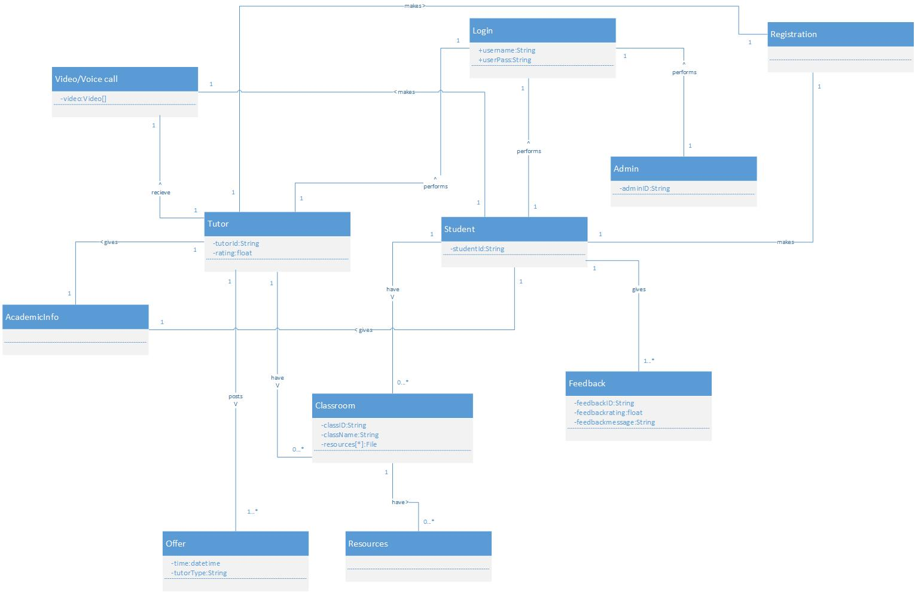

*Figure 3: Domain Model*

# VII. System Sequence Diagram

Following are all SSDs of Seekhloo.

## 1. Registration

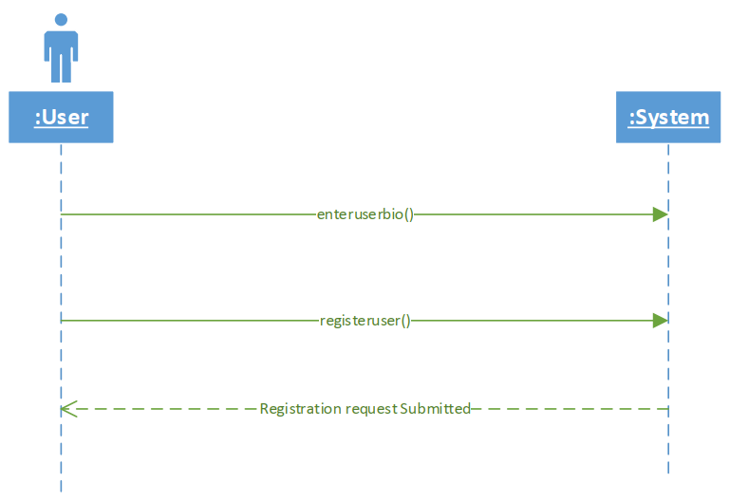

*Figure 4: Registration*

## 2. Enter academic information

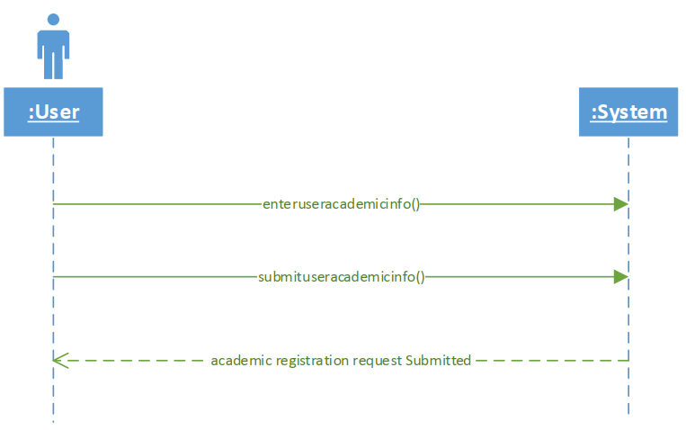

*Figure 5* *Enter academic information*

## 3. Login

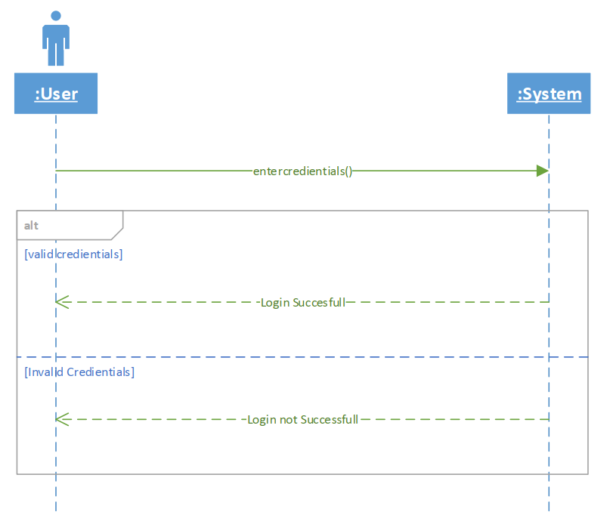

*Figure 6: Login*

## 4. Share resources

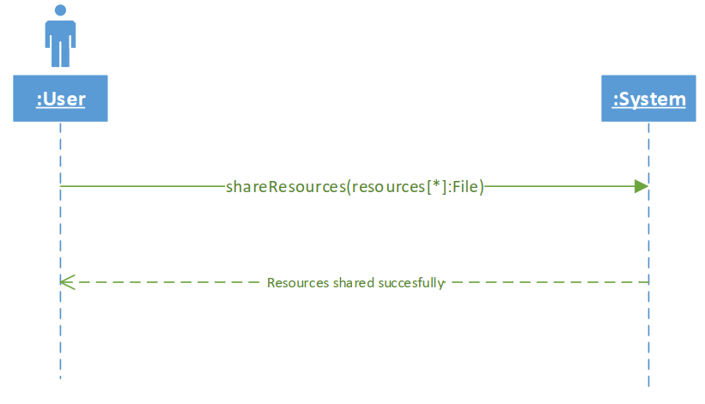

*Figure 7: Share resources*

## 5. Post offer

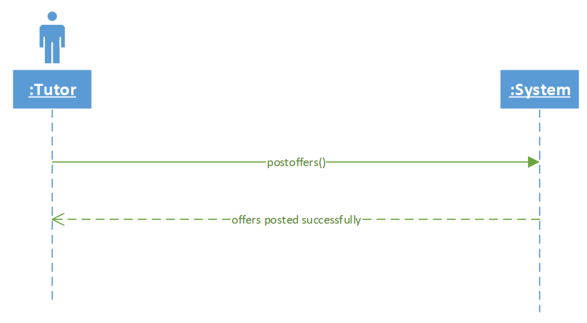

*Figure 8: Post offer*

## 6. Create classroom

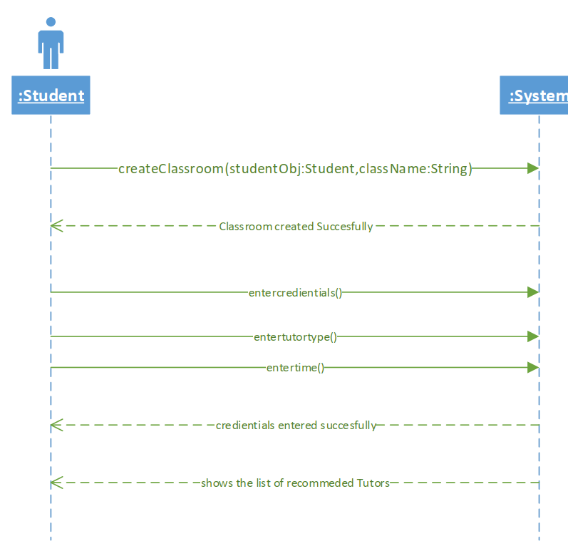

*Figure 9: Create classroom*

## 7. Gives feedback

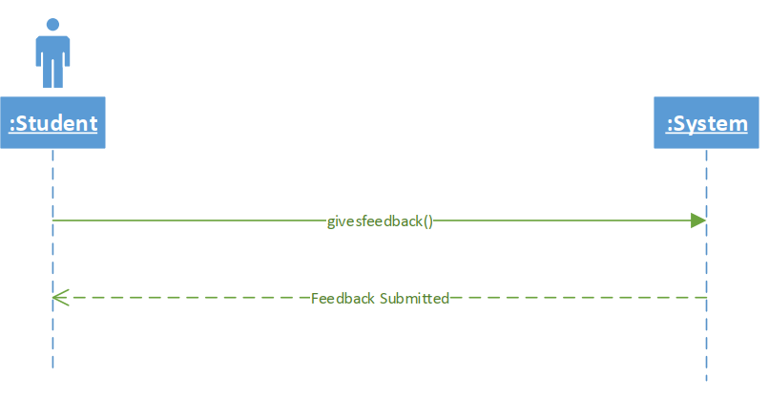

*Figure 10: Gives feedback*

## 8. Select tutor

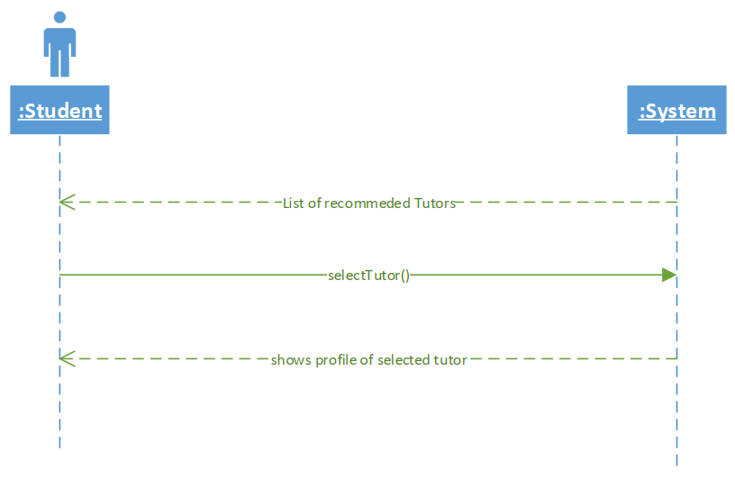

*Figure 11: Select tutor*

## 9. Send request to tutor

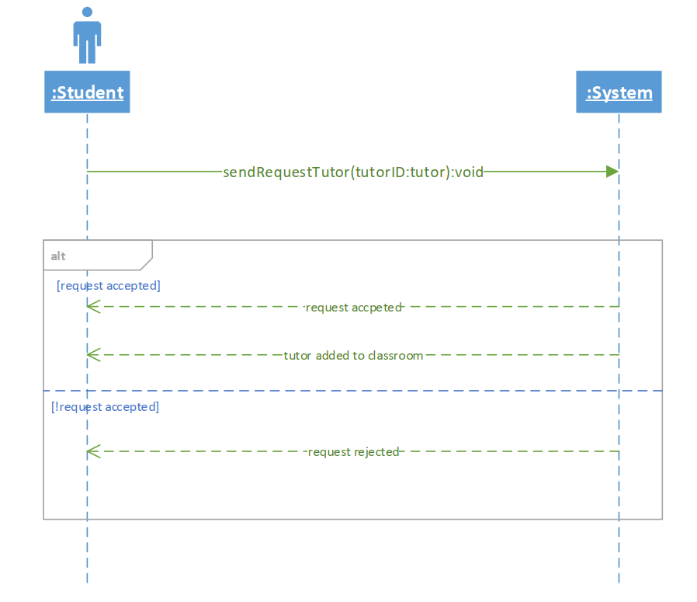

*Figure 12: Send request to tutor*

## 10. Make videocall

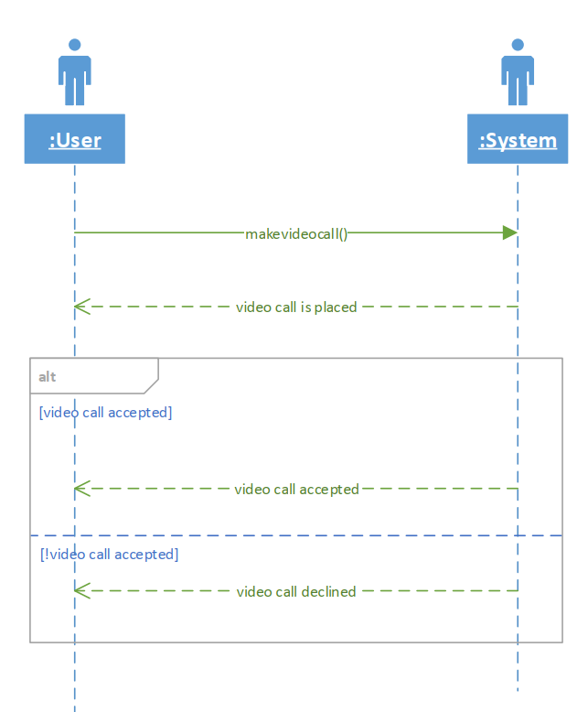

*Figure 13: Make videocall*

## 11. Post newsletters

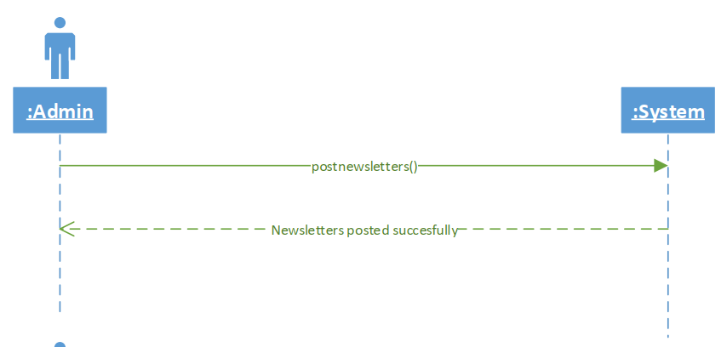

*Figure 14: Post newsletter*

## 12. Read newsletter

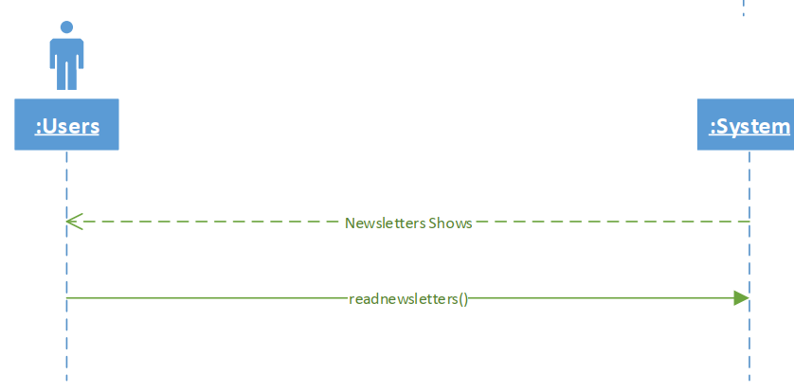

*Figure 15: Read newsletter*

## 13. Gives personality test

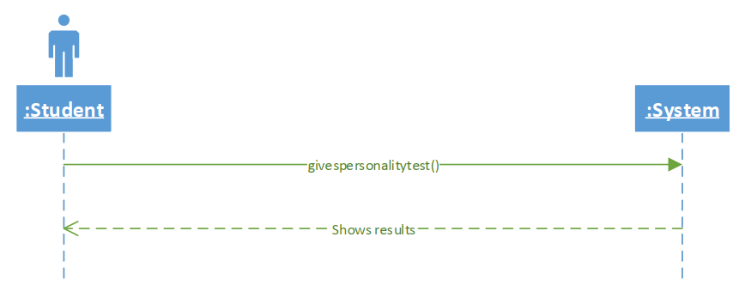

*Figure 16: Gives personality test*

## 14. React requests

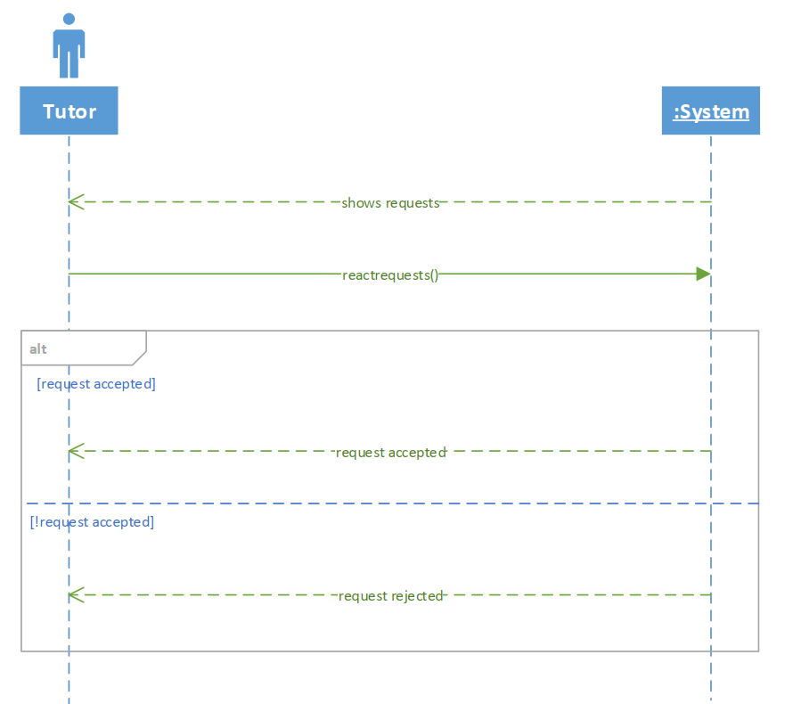

*Figure 17: React requests*

# VIII. Operational Contracts

## 1. Login

*Table 27: Login*

|  |  |
| --- | --- |
| Name: | Login() |
| Responsibility: | This method verifies user account. |
| Type: | System |
| Cross Reference: | Use Case: Login |
| Output: | User logged in |
| Exception: | Invalid credentials, generate error. |
| Pre-Condition: | User ID and Password is known. |
| Post-Condition: | * Account instance is created. * Association of Account class with User class is created. * Login() method is invoked. |

## 2. Create Classroom

*Table 28: Create Classroom*

|  |  |
| --- | --- |
| Name: | CreateClassroom () |
| Responsibility: | This method allow student to create a common classroom to interact with tutor |
| Type: | System |
| Cross Reference: | Use Case: Create classroom |
| Output: | Give successful message after creating a classroom |
| Exception: | Failed to make classroom, generate error. |
| Pre-Condition: | Student should be logged in. |
| Post-Condition: | * Classroom instance created. * Student class associated with Classroom * CreateClassroom() is invoked |

## 3. Find Tutor

*Table 29: Find Tutor*

|  |  |
| --- | --- |
| Name: | FindTutor() |
| Responsibility: | This method searches for the best suitable tutors according to student need. |
| Type: | System |
| Cross Reference: | Use Case: Find Tutor |
| Output: | Generate a list of recommended tutors |
| Exception: | No tutor exists, generate error. |
| Pre-Condition: | * Student should be logged in * Classroom should be created by the student |
| Post-Condition: | * Tutor instance created. * Tutor class associated with classroom * Findtutor() is invoked. |

## 4. Request Tutor

*Table 30: Request Tutor*

|  |  |
| --- | --- |
| Name: | RequestTutor() |
| Responsibility: | This method send request to the tutor in which student is interested. |
| Type: | System |
| Cross Reference: | Use Case: Request Tutor |
| Output: | Send a request to tutor |
| Exception: | No such tutor exists, generate error. |
| Pre-Condition: | No tutor assigned to classroom. |
| Post-Condition: | * Tutor instance created. * Tutor class associated with classroom. * RequestTutor() is invoked. |

## 5. React to request

*Table 31: React to request*

|  |  |
| --- | --- |
| Name: | ReactToRequest() |
| Responsibility: | This method set tutor status to a classroom. |
| Type: | System |
| Cross Reference: | Use Case: React to request |
| Output: | Accept or decline request. |
| Exception: | Student deletes classroom. |
| Pre-Condition: | Request must be sent to tutor |
| Post-Condition: | * Tutor instance created. * Tutor class associated with classroom. * ReactToRequest() is invoked. |

## 6. Give Feedback

*Table 32: Give Feedback*

|  |  |
| --- | --- |
| Name: | GiveFeedback() |
| Responsibility: | This method record feedback of student about tutor |
| Type: | System |
| Cross Reference: | Use Case: Give feedback |
| Output: | Feedback recorded. |
| Exception: | Student didn’t give feedback. |
| Pre-Condition: | Student currently taught by tutor |
| Post-Condition: | * Feedback instance created. * Feedback class associated with tutor class. * GiveFeedback() is invoked. |

## 7. Enter Academic Information

*Table 33: Enter Academic Information*

|  |  |
| --- | --- |
| Name: | EnterAcademicInformation() |
| Responsibility: | It records user academic information to the system. |
| Type: | System |
| Cross Reference: | Use Case: Enter Academic Information |
| Output: | Show dialogue Information recorded successfully |
| Exception: | If user enter incorrect information, generate error. |
| Pre-Condition: | User logged in. |
| Post-Condition: | * Academicinfo instance creates. * EnterAcademicInfornation() is invoked. |

## 8. Post Newsletter

*Table 34: Post Newsletter*

|  |  |
| --- | --- |
| Name: | PostNewsletter() |
| Responsibility: | Its responsibility is to publish newsletter. |
| Type: | Admin |
| Cross Reference: | Use Case: Post Newsletter |
| Output: | Published successfully. |
| Exception: | Not published, generate error. |
| Pre-Condition: | Admin should be logged in. |
| Post-Condition: | * Admin instance created. * User class associated with admin. * PostNewsletters() is invoked. |

## 9. Receive Video Call

*Table 35: Receive Video Call*

|  |  |
| --- | --- |
| Name: | ReceiveVideoCall() |
| Responsibility: | Its responsibility is to initiate a video conference between student and tutor. |
| Type: | System |
| Cross Reference: | Use Case: Video Call |
| Output: | Both user connected via video call. |
| Exception: | Connection not created, generate error. |
| Pre-Condition: | User is registered as student or tutor. |
| Post-Condition: | * User instance is created. * Classroom class associated with student/tutor class. * ReceiveVideoCall() is invoked. |

## 10. Request Video Call

*Table 36: Request Video Call*

|  |  |
| --- | --- |
| Name: | RequestVideoCall() |
| Responsibility: | Its responsibility is to request a video call. |
| Type: | System |
| Cross Reference: | Use Case: Request video call |
| Output: | Ringing on other user phone |
| Exception: | Connection not created, generate error |
| Pre-Condition: | Tutor is online. |
| Post-Condition: | * Classroom instance created. * Tutor class associated with classroom class. |

# 

# IX. Sequence Diagram

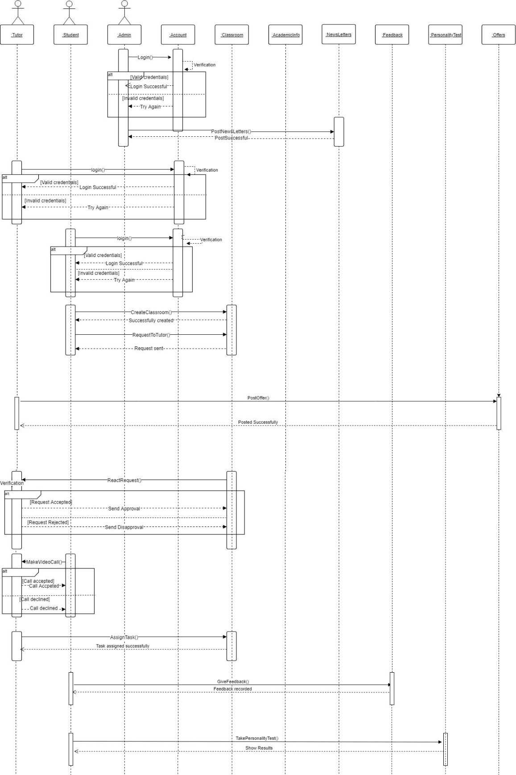

*Figure 23: Sequence Diagram*

# X. Class Diagram

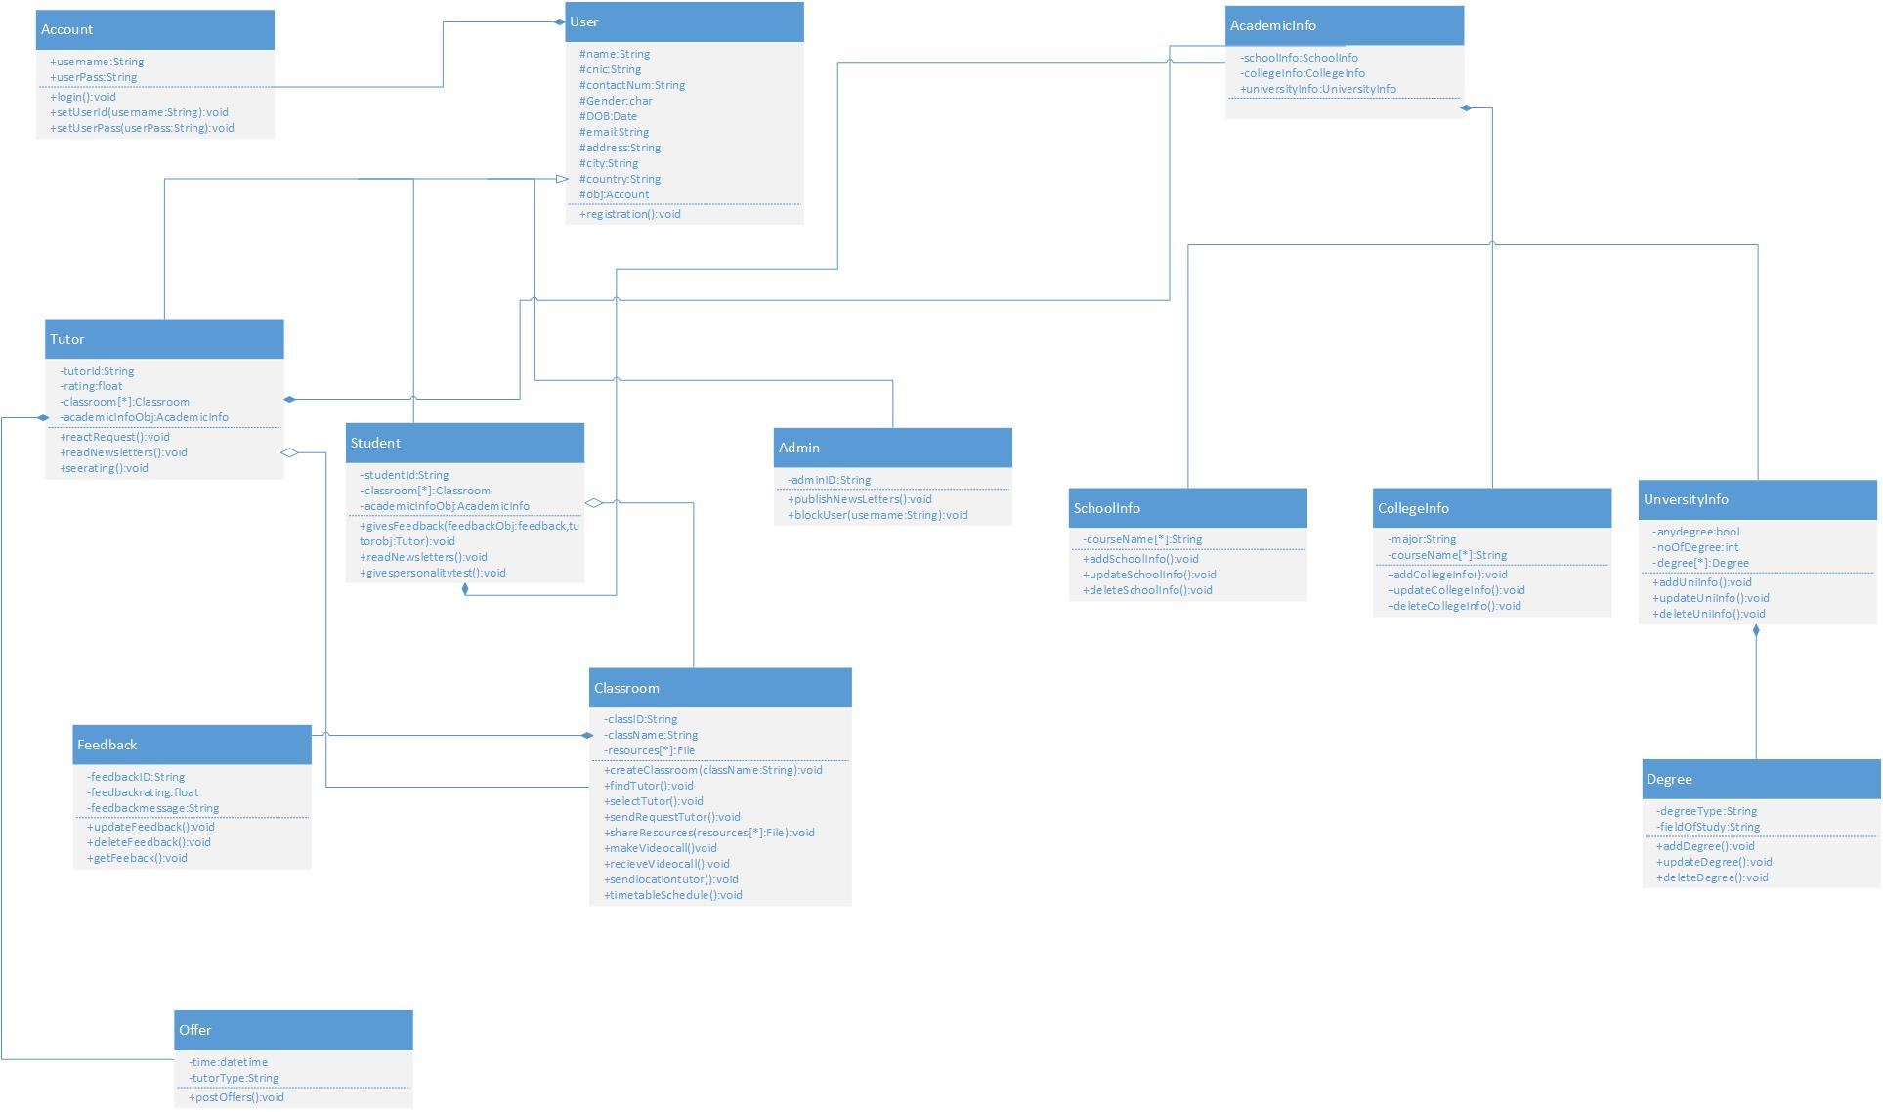

*Figure 24: Class Diagram*

# XII. Activity Diagram

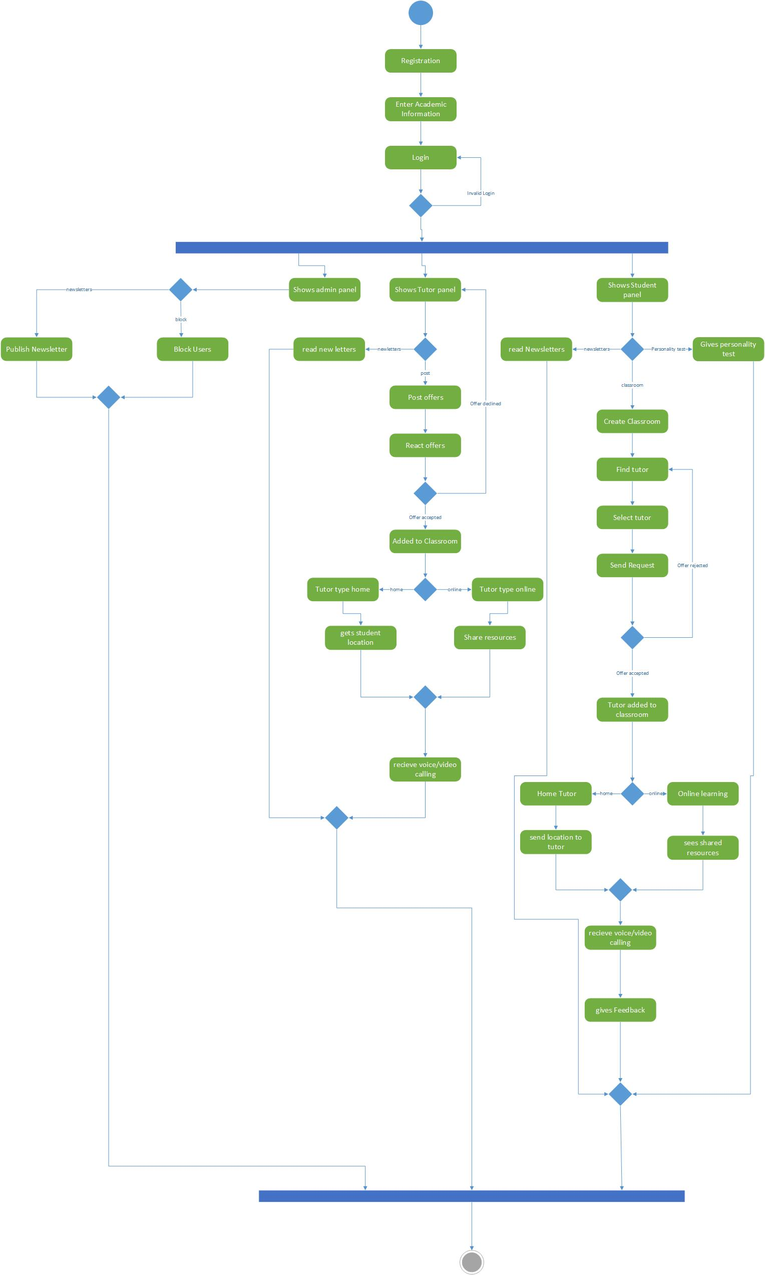

*Figure 26: Activity Diagram*